**Question 6**

Use SSMS to generate a script to create the authors table describe what the script does

**Answer:**

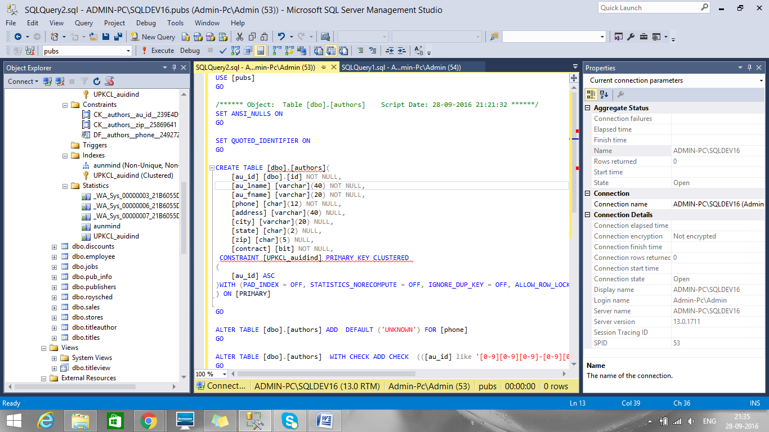

* USE [pubs]

Uses database pubs

* GO

Go will execute commands in sql for pubs database.

* SET ANSI_NULLS ON

Specifies ISO compliant behaviour of the Equals (=) and Not Equal To (<>) comparison operators when they are used with null values in SQL Server 2016

* SET QUOTED_IDENTIFIER ON

Causes SQL Server to follow the ISO rules for quotation mark, delimiting identifiers and literal strings. Identifiers delimited by double quotation marks can be either Transact-SQL reserved keywords or can contain characters not generally allowed by the Transact-SQL syntax rules for identifiers.

* CREATE TABLE [dbo].[authors]

Creates table authors for pubs database with mentioned column names , data types and constraints.

* CONSTRAINT [UPKCL_auidind]

The action is aborted by the constraint au_id which indexed, if there is any violation between the constraint and the data action.

* PRIMARY KEY CLUSTERED

The PRIMARY KEY constraint uniquely identifies each record in a database table authors. The word clustered means it has typical index order for row.

* ASC

Sets ascending order for data

* PAD_INDEX = OFF

Fill factor is not specified: The intermediate-level pages are filled to near capacity, leaving sufficient space for at least one row of the maximum size the index can have, considering the set of keys on the intermediate pages.

* STATISTICS_NORECOMPUTE = OFF,

Stops the database-wide auto-updating (auto update statistics) from updating the specific statistics for an index (or column-level statistic)

* IGNORE_DUP_KEY = OFF,

A duplicate key value causes an error and the entire statement is rolled back. That is, if the statement attempted to insert multiple rows, no rows are inserted.

* ALLOW_ROW_LOCKS = ON, ALLOW_PAGE_LOCKS = ON

QL decides on which lock level to create according to the amount of rows and memory available.

* ALTER TABLE [dbo].[authors] ADD DEFAULT ('UNKNOWN') FOR [phone]

The ALTER TABLE statement is used to add default value for column UNKNOWN for table authors.

* ALTER TABLE [dbo].[authors] WITH CHECK ADD CHECK (([au_id] like '[0-9][0-9][0-9]-[0-9][0-9]-[0-9][0-9][0-9][0-9]'))

The first syntax is redundant - the WITH CHECK is default for new constraints, and the constraint is turned on by default as well for au_id.

|  |  |
| --- | --- |
|  |  |

**Question 7**

 Describe what the au_id is using for a data type

**Answer:**

* Default schema for user defined data type as 'dbo'
* Name for user defined data type as ‘au_id’
* Data type for user defined data type as 'varchar'
* Length of user defined data type as 11
* Allow NULLs is unchecked, so NULL will not be allowed for this data type.
* As a default I have browsed a pre created default ‘dbo.id’
* As a rule for this user defined data type I have browsed a pre created rule 'dbo.rule_id'